 | 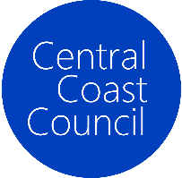
COUNCIL ASSESSMENT REPORT
HUNTER AND CENTRAL COAST REGIONAL PLANNING PANEL

PANEL REFERENCE & DA NUMBER | PPSHCC-118 – DA/1888/2021
PROPOSAL | 4 x 2 storey residential flat buildings comprising a total of 160 dwellings, civil services and associated landscaping
ADDRESS | Lot 11 DP 1252673 – 94 Sparks Road, Hamlyn Terrace
APPLICANT | Rachael Petherbridge / Gyde Consulting
OWNER | Raj & Jai Construction Pty Ltd
DA LODGEMENT DATE | 9 February 2022
APPLICATION TYPE | Development Application
REGIONALLY SIGNIFICANT CRITERIA | Clause 2, Schedule 6 of State Environmental Planning Policy (Planning Systems) 2021 – Development that has a capital investment value of more than $30 million.
CIV | $35,851,680.00 (excluding GST)
CLAUSE 4.6 REQUESTS | N/A
KEY SEPP/LEP | - State Environmental Planning Policy (Planning Systems) 2021  - State Environmental Planning Policy 65 – Design Quality of Residential Apartment Development  - State Environmental Planning Policy (Transport and Infrastructure) 2021;  - State Environmental Planning Policy (Resilience and Hazards) 2021 (Resilience and Hazards SEPP)  - State Environmental Planning Policy (Building Sustainability Index: BASIX) 2004;  - State Environmental Planning Policy (Biodiversity and Conservation) 2021  - Wyong Local Environmental Plan 2013  - Central Coast Local Environmental Plan 2022
TOTAL & UNIQUE SUBMISSIONS | No public submissions received  Referrals received from Transport for NSW and NSW Rural Fire Service
DOCUMENTS SUBMITTED FOR CONSIDERATION | Attachment 1: Draft reasons for refusal  Attachment 2: Architectural Plans  Attachment 3: Statement of Environmental Effects
SPECIAL INFRASTRUCTURE CONTRIBUTIONS (S7.24) | N/A
RECOMMENDATION | Refusal
DRAFT CONDITIONS TO APPLICANT | N/A
SCHEDULED MEETING DATE | 8 March 2023
PLAN VERSION | November 2021
PREPARED BY | Padraig Scollard, Associate, Keylan Consulting Pty Ltd on behalf of Central Coast Council
DATE OF REPORT | 7 February 2023

EXECUTIVE SUMMARY
The development application seeks consent for 4 x 2 storey residential flat buildings comprising a total of 160 dwellings, civil services and associated landscaping at 94 Sparks Road, Hamlyn Terrace (the site).

The site is a large vacant lot that is generally rectangular in shape. The subject application relates to a portion of 94 Sparks Road, specifically the R1 General Residential zoned part of the site.

Residential flat buildings are permitted with consent within the R1 General Residential Zone under the Wyong Local Environmental Plan 2013 (WLEP 2013).

On 4 February 2021, Central Coast Council granted consent for a residential subdivision at 94 Sparks Road comprising of 88 lots, including small lot housing, demolition and associated site establishment works (Development Application DA/1176/2017).

On 30 November 2021, a modification application DA/1176/2017/A was lodged with Central Coast Council. In particular, this modification application sought to amend DA/1176/2017 to consolidate 33 lots into 1 large residue lot. The intent for this residue lot was to contain the residential flat buildings subject of this development application.

On 13 July 2022, Central Coast Council refused modification application DA/1176/2017/A for the following reasons:

- The consent authority was not satisfied that the development is substantially the same development as the development for which the consent was originally granted.
- The consent authority was not satisfied that objectives of the R1 General Residential zone were being met.
- The application does not comply with the objectives and controls of Chapter 6.5 – Warnervale South.
- The application did not contain sufficient information to accurately represent the proposed development or to properly assess the likely impacts of the development.

The subject application is therefore inconsistent with the underlying approved subdivision pattern.
The Central Coast Local Environmental Plan 2022 (CCLEP 2022) came into effect on 1 August 2022. This application is subject to saving provisions under clause 1.8A of CCLEP 2022 and as such must be determined as if this plan had not commenced.

An assessment of the proposal has been undertaken against the following relevant planning instruments:

- State Environmental Planning Policy (Planning Systems) 2021
- State Environmental Planning Policy 65 – Design Quality of Residential Apartment Development
- State Environmental Planning Policy (Transport and Infrastructure) 2021;
- State Environmental Planning Policy (Resilience and Hazards) 2021 (Resilience and Hazards SEPP)
- State Environmental Planning Policy (Building Sustainability Index: BASIX) 2004;
- State Environmental Planning Policy (Biodiversity and Conservation) 2021
- Wyong Local Environmental Plan 2013
- Central Coast Local Environmental Plan 2022

The proposal was also referred to Councils relevant internal teams (Engineering, Traffic, Environmental Health, Biodiversity, Waste and Urban Design) and external agencies (RFS and TfNSW). Significant issues were raised in both the internal and external referrals and a request to withdraw the application was issued to the applicant on 29 June 2022.

The applicant advised they were not willing to withdraw the application and requested to address the issues raised in the correspondence. The extent of deficiencies and non-compliances are such that the proposal cannot be supported in its current form, and the changes required to comply with the relevant plans and policies are deemed insurmountable to the subject application. As such, the decision was made to progress the application to determination based on the information currently available.

The application is referred to the Hunter and Central Coast Regional Planning Panel (the Panel) for determination as the development is ‘regionally significant development’, pursuant to Clause 2 of Schedule 6 of State Environmental Planning Policy (Planning Systems) 2021. A briefing was held with the Panel on 9 June 2022

The key issues associated with the proposal include:

- Context, Setting and the Built Environment
- Residential Amenity
  - Building Separation and Privacy
  - Unit Mix and Apartment Layout
  - Private Open Space
  - Communal Open Space
  - Solar Access
- Car Parking
- Waste Collection
- Acoustic Impacts
- Stormwater Management
- Inconsistency with DA/1176/2017
- Insufficient Information

Following a thorough assessment of the matters for consideration under section 4.15 of the EP&A act, the relevant planning controls, issues raised in referrals and the key issues identified in this report, it is considered that the application cannot be supported.

It is therefore recommended that Development Application DA/1888/2021 be refused.

- THE SITE AND LOCALITY

  - The Site

The site is located at 94 Sparks Road, Hamlyn Terrace and is legally described as Lot 11 DP 1252673. The site is located on the southern side of Sparks Road, opposite the intersection of Sparks Road and Woongarrah Road.
The site is generally rectangular in shape with a frontage of approximatley 200m to Sparks Road and a depth of 350m (Figure 1).
The subject application relates to a portion of 94 Sparks Road, specifically the R1 General Residential zoned part of the site, which has an area of approximately 27,400m² (Figure 2).

It is noted that the the architectural plans submitted with the application state the site has an area of 19,671m², which appears to be an inconsistency in the plans.

On 4 February 2021 Central Coast Council granted consent under Development Application DA/1176/2017 for a residential subdivision at the site comprising of 88 lots, including small lot housing, demolition and associated site establishment works. This approval is discussed in detail in Section 2 of this report.

The wider site is currently vacant of buildings; however, it previously contained a rural residential dwelling and associated outbuildings which have recently been demolished.

The site is heavily vegetated, containing a number of large trees as illustrated in the below figures. The clearing of the existing vegetation within the site is approved under DA/1176/2017.

Due to the vegetation within the site and the surrounding area, the site is identified as bushfire prone land.

A portion of 94 Sparks Road is mapped as being within a Flood Planning Area. However, the proposed development is located on a portion of the site which is not identified as containing flood prone land.

The topography of the site falls from Sparks Road to the southern boundary by approximately 10m.

Access to the site is currently from the north western end of Sparks Road. However, DA/1176/2017 includes the construction of a north-south collector road, which connects to Woongarrah Road and provides access to the site. The proposed development site is located to the east of the collector road and within the portion of 94 Sparks Road.

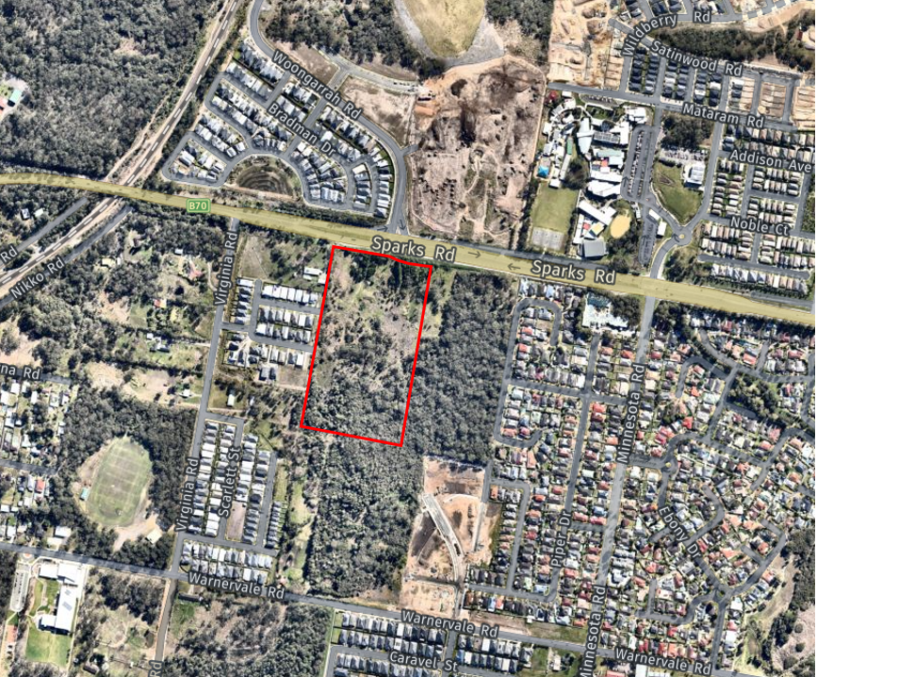
Figure 1: 94 Sparks Road outlined in red
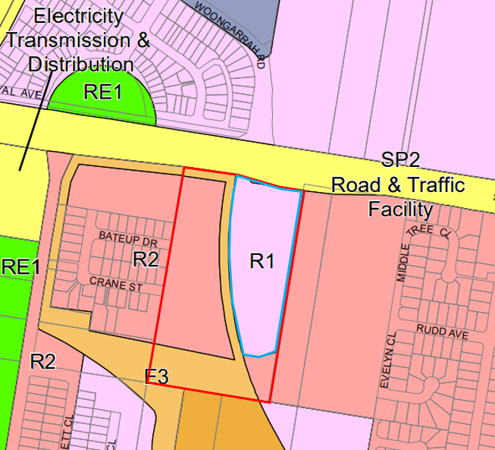
Figure 2: 94 Sparks Road outlined in red, the site of the proposed development outlined in blue
  - The Locality

The site is located within Warnervale, approximately 5km from the Pacific Motorway providing access to the south towards Sydney and to the north towards Newcastle. The locality consists of a mix of land uses, including low density residential, educational establishments, village shopping centres, open space and other recreational facilities. The area immediately adjoining the site is residential and semi-rural residential.

The Warnervale Town Centre is located to the north of the site and is currently undergoing development. The Great Northern Railway is located 430m to the west of the site whilst a private catholic college is located to the north-east of the site.

Sparks Road is a primary arterial road and provides access to the wider road network.

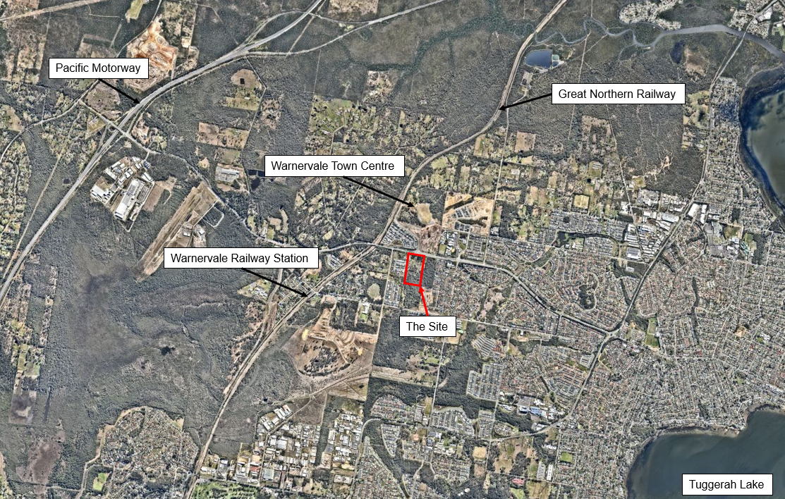
Figure 3: Site locality (Base source: Nearmap)
- THE PROPOSAL AND BACKGROUND

  - The Proposal

The development application seeks consent for 4 x 2 storey residential flat buildings comprising a total of 160 dwellings, civil services and associated landscaping.

Specifically, the proposal involves:

- Building A
- 66 car parking spaces at basement level
- 18 dwellings on the ground floor
- 19 dwellings on the first floor
- private terrace areas associated with the dwellings;

- Building B
- 88 car parking spaces at basement level
- 24 dwellings on the ground floor
- 24 dwellings on the first floor
- private terrace areas associated with the dwellings;
- Building C
- 83 car parking spaces at basement level
- 25 dwellings on the ground floor
- 25 dwellings on the first floor
- private terrace areas associated with the dwellings;
- Building D
- 41 car parking spaces at basement level
- 12 dwellings on the ground floor
- 13 dwellings on the first floor
- private terrace areas associated within the dwellings;

- Construction of a private driveway to the east of the site accessed via the Collector Road which provides 24 visitor car parking spaces and four driveway access points to the basement car parking;
- Associated landscaping across the site; and
- An APZ proposed to the east of the site.

Key development data for the proposal are provided within the table below:

Table 1: Development Data
Control | Proposal
Site area | 27,400m²
GFA | 11,260m²
FSR | 0.57:1
Clause 4.6 Requests | No
No of apartments | 160
Max Height | ~7.6m
Landscaped area | 7,381 (38% of site)
Car Parking spaces | 302 (277 residential and 25 visitor spaces)

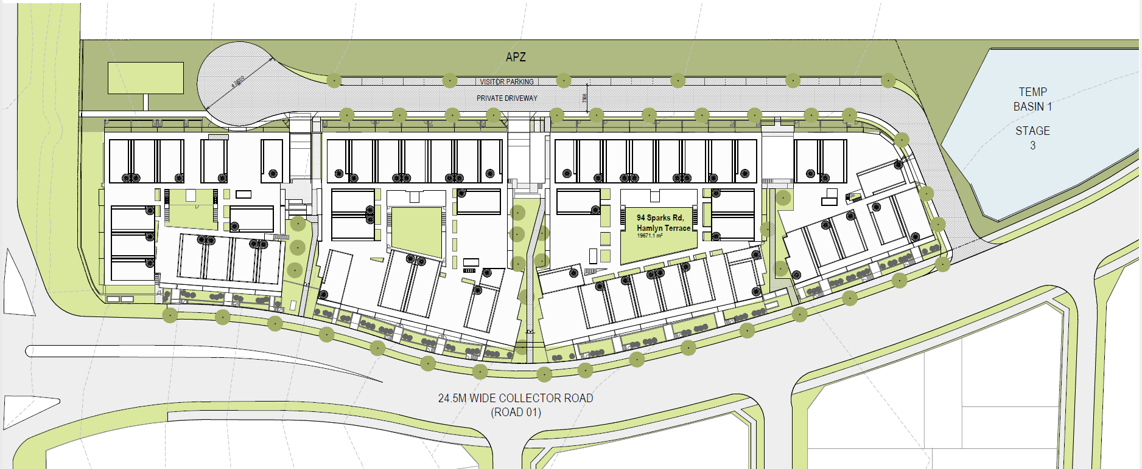
Figure 4: Proposed Site Plan (Source: Rothlowman)
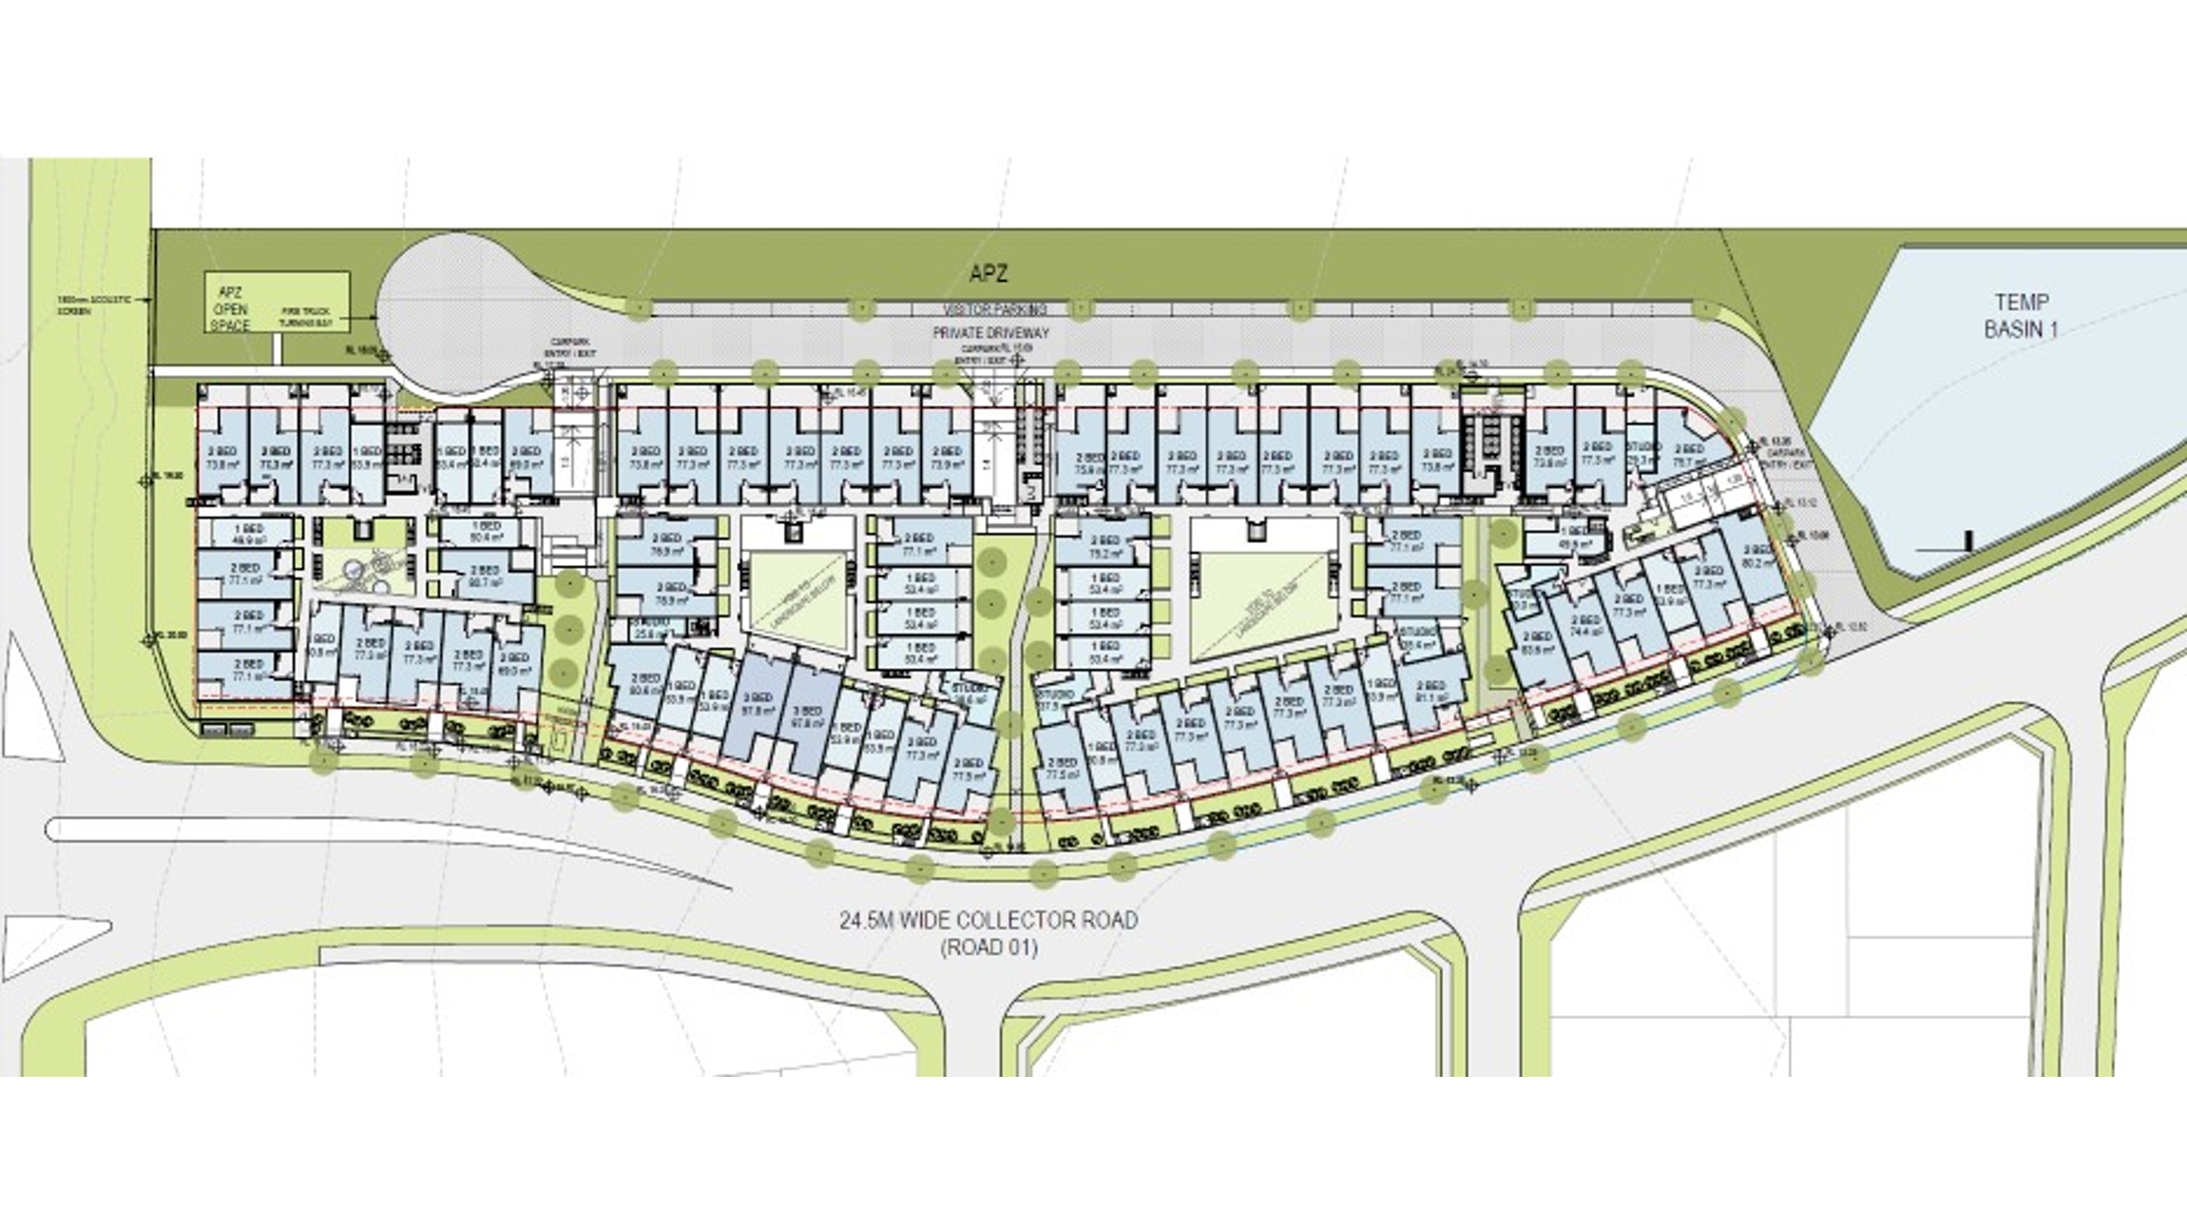
Figure 5: Ground floor plan (Source: Rothlowman)
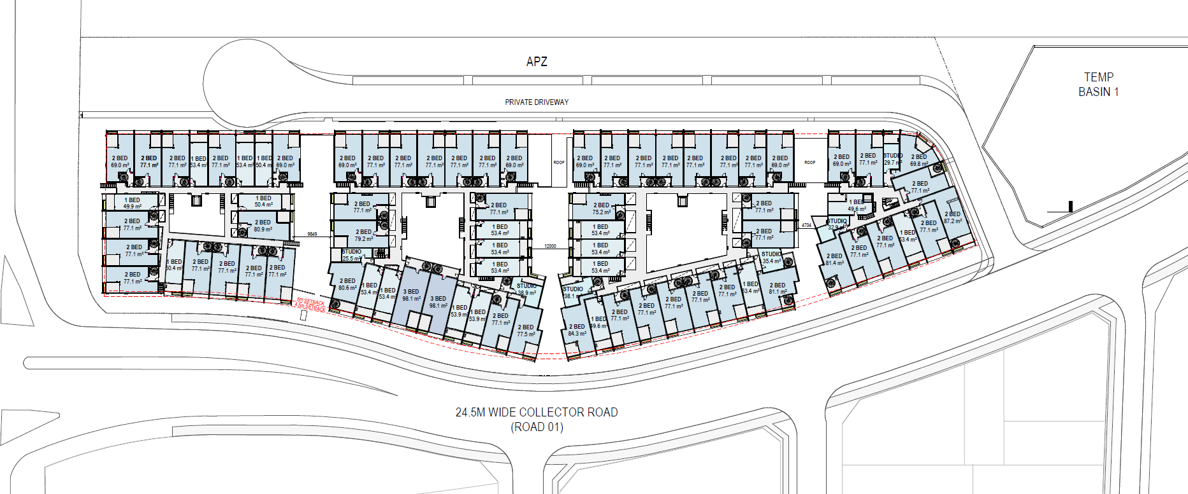
Figure 6: First floor plan (Source: Rothlowman)

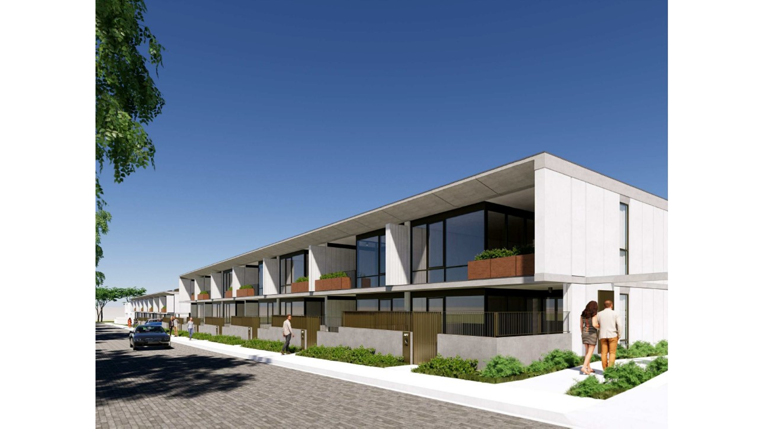
Figure 7: Perspective - eastern facade viewed from private road (Source: Rothlowman)
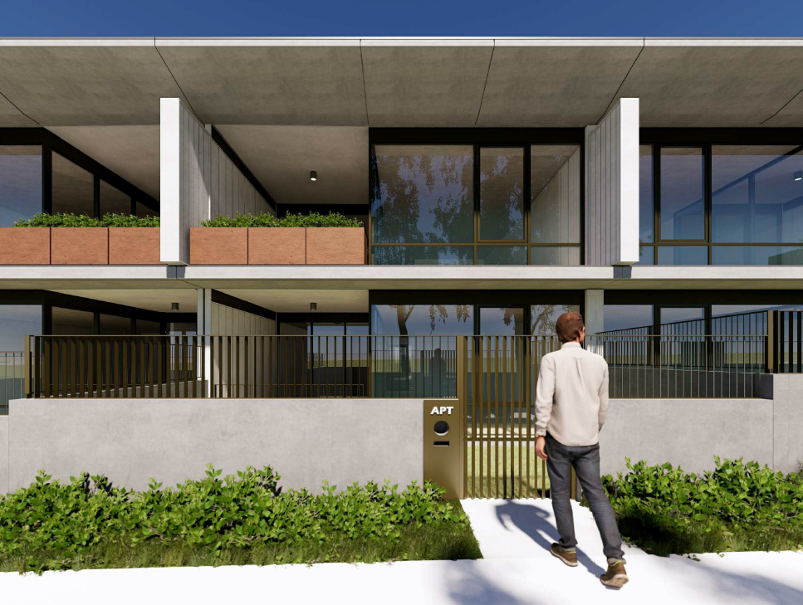
Figure 8: Perspective of eastern elevation (Source: Rothlowman)
  - Background

The development application was lodged on 9 February 2022. A chronology of relevant events is outlined below including the Panel’s involvement (briefings, deferrals etc) with the application:

Table 2: Chronology of the DA
Date | Event
2 August 2021 | Pre-Development Meeting held
9 February 2022 | DA lodged
9 February 2022 | DA referred to external agencies
3 March 2022 | Request for additional information from TfNSW
23 March 2022 | Request for additional Information from NSW RFS
22 April 2022 | Additional information submitted by applicant to address TfNSW comments.
10 June 2022 | Request for further information from TfNSW
14 June 2022 | Panel briefing
29 June 2022 | Request to withdraw issued by Council to applicant
22 August 2022 | Request for further information from NSW RFS
December 2022 | Keylan Consulting Pty Ltd engaged to undertake the assessment of this application on behalf of Central Coast Council
19 January 2023 | NSW RFS advised they cannot support the proposed development as the requested information was not provided.
  - Panel Briefings

On 14 June 2022 the Hunter and Central Coast Regional Planning Panel were briefed on the proposed development. The following key issues were identified.

Key Issue | Comments | Resolved
Calculation of FSR | The proposal has not calculated Gross Floor Area (GFA) in accordance with the LEP definition as follows:  - Gross Floor Area calculations submitted do not include parking areas within the basement that are above the parking required by Wyong Development Control Plan (WDCP)  - Gross Floor Area calculations submitted have not included internal hallways  - The plans illustrate an entryway into dwellings which haven’t been included in the GFA calculations. It is unclear from the plans submitted whether these spaces have enclosing walls greater than 1.4m and as such whether they are to be included in the GFA calculations. | No
Height | - Chapter 2.4 of WDCP requires that multiple dwelling residential development shall not exceed two storeys and 7 metres in height. The plans submitted with the application do not include RLs for the top of the building (privacy screening) and as such the maximum building height could not be accurately determined.  - Notwithstanding the above, the development exceeds the 7m height limit by over 500mm and the development results in adverse impacts on solar access and privacy and does not provide adequate amenity for future occupants of the development for the reasons outlined in this report.  - The proposal includes terraces on the rooftop which adds additional bulk to the development and results in a poor amenity outcome for future residents in terms of privacy.  - In addition to the above, the plans submitted do not provide RLs to detail the extent of excavation proposed. Part 4.2 of Chapter 2.4 of WDCP contains requirements for cut and fill to ensure development responds to the natural topography of the site. It is unclear from the documentation submitted whether the cut is consistent with the requirements of WDCP.  - It is considered that the height variation as well as extent of excavation proposed results in a development that is out of scale with the desired future character for the area and is inconsistent with the objectives and controls relating to height contained in Chapter 2.4 of WDCP. | No
Setbacks | The proposed development is subject to the setback controls in the WDCP Chapter 2.4 Multiple Dwelling Residential Development. Part 4.3.2 outlines the setback requirements for Multi dwelling housing or RFBs no greater than 2-storeys in height. The proposal breaches these controls as follows:  - The proposed development has a northern boundary to Sparks Road which is a Category A road. All development to this boundary must be set back 7.5 metres. The proposed development encroaches on this setback in the north-west corner.  - The proposed development has a 24.5 metre wide collector road on the western side. The former Wyong Shire Council defined a Collector Road as a Category B road. Therefore, the development must provide a 6 metre front building setback to this road (4.5 metres proposed).  - The internal driveway services 160 apartments and car parking for 302 vehicles has been provided. As such, the internal driveway is characteristic of a Category C Road and the proposed development should be set back in accordance with a Category C road.  - In addition to the point above, the setback should be from the “boundary” line, not the line of the bitumen, similar to the setback from a road to the front boundary. This virtual line should allow for ample space for services, footpaths and turning into basement access ramps without requiring a 3 point turn. | No
Privacy | Part 6.4 Privacy of Chapter 2.4 Multiple Dwelling Residential Development of WDCP outlines the minimum separation distances and other requirements to provide reasonable levels of visual and acoustic privacy. The proposal breaches these controls as follows:  - The separation between living areas is less than 6m in some instances within buildings A and B and between Buildings C and D and is not sufficient to provide adequate amenity.  - The proposal includes terraces on the rooftop which have low walls separating terraces from one another which are inadequate to mitigate privacy impacts. This results in low levels of privacy for future occupants of the development and will be unusable.  - These rooftop terraces also contribute to the overall bulk of the development and result in a streetscape outcome that is inconsistent with the future character of the locality. | No
Solar Access | - Chapter 2.4 Multiple Dwelling Residential Development of WDCP is applicable to the development. Section 6.3 outlines the requirements for Solar Access. The objectives of this section are:  - To provide adequate natural lighting and minimise the need for artificial lighting during daylight hours  - To ensure that a minimum standard of solar access is available to private open space areas and internal living areas during the winter solstice to provide for a reasonable standard of residential amenity  - The site of the proposed development is generally aligned north-south with good solar access opportunities to the north, east and west. However, the proposed development has many apartments (circa 70%) that are aligned with the internal driveway or the south part of the collector road. These apartments will not be able to achieve at least 3 hours of solar access in mid-winter due to their orientation.  - In addition, numerous dwellings are set below natural ground level and will have overshadowing caused by the boundary fences and retaining walls.  - There are a number of units within the development that have no windows to the living areas. For example, in Building D on level 1 unit 112 is a studio unit where the living area is at the back of the unit with no access to daylight.  - Given the above, the proposal has not been designed to maximise solar acces for future occupants of the development and is inconsistent with the objectives and requirements of Section 6.3 of the Wyong DCP. | No
Apartment Layout | - There are a number of apartments that have inadequate floor area and provide a layout that does not allow for basic furnishings. Using the minimum areas prescribed under the Apartment Design Guide (ADG) there are a substantial number of dwellings proposed that are inconsistent with these minimum dimensions.  - Specifically, the studios proposed are substantially undersized when compared to the ADG minimum standards and the 1 and 2 bedroom units are all below the standards prescribed by the ADG. While the development is not subject to the ADG, the ADG has been referenced as a best practice guide for apartment design. | No
Private Open Space | The proposed development is subject to the private open space controls in the WDCP Chapter 2.4 Multiple Dwelling Residential Development. Part 6.1 Private Open Space outlines the requirements. The proposal breaches these controls as follows:  - More than 10% of the units proposed do not provide adequate private open space in accordance with the requirements of the Wyong DCP.  - Furthermore, the usability of the private open space is limited in many cases due to the layout where the spiral staircase has been located in the centre of the private open space. Therefore, a significant number of units do not have any usable private open space that is directly accessible from internal living areas. This results in units relying on the rooftop terraces and as for reasons discussed above these spaces have limited visual and acoustic privacy and contribute to unacceptable bulk and a scale impacts and height breaches. | No
Communal Open Space | The proposed development is subject to the communal open space controls in the WDCP Chapter 2.4 Multiple Dwelling Residential Development. Part 6.2 Communal Open Space outlines the requirements. The communal open space is required to be at ground level, be landscaped and provide the provision of facilities. It must be designed to be useable and attractive. The proposal breaches these requirements as follows:  - The proposed development has communal open space at basement level, not ground level. It is not directly accessible or usable.  - There are no facilities proposed for residents. | No
Public Domain/ Pedestrian Access | The proposed development is subject to WDCP Chapter 2.4 Multiple Dwelling Residential Development, Section 4.0 Built Form. This requires that new development activates the street and promotes development that is well connected to the street and enhances the public domain. The proposal breaches these requirements as follows:  - The proposed development has a length of approximately 230 metres. The ground floor provides a continuous single storey to the internal driveway. It will be very difficult to discern the separation of the buildings into the 4 blocks. The proposed development should be broken up into legible parts.  - There is no unique identifier to the pedestrian corridors leading from the internal driveway into the site. There are no lobby areas or centralised entry points to provide clear pedestrian connections into the site.  - With respect to the apartments next to the proposed Waste Storage, the impact on the amenity of the occupants arising from the collection and storage of waste has not been adequately considered. | No
Access and Traffic | Private Driveway  - In 2012, Council engaged Hyder Traffic Consultants to undertake a Traffic and Transport Study for the planning area known as Precinct 7A. The purpose of Hyder’s traffic study is to assess the performance of existing and future network capacity within the study area. Hyder used the RMS’s Central Coast Regional Strategic Model together with its own TransCAD modelling software. For assessing individual intersection capacity, Hyder used SIDRA software. Future years modelling was undertaken for 2021 and 2031 using land use data sourced from Council. The traffic model included the cumulative growth from planned developments in the locality. Therefore, Council has considered the cumulative effects of this and other proposed developments in the greater Warnervale area.  - The applicant proposes a private driveway to access the development consisting of 160 living units. This proposal is not supported, and the entry road is to be dedicated as a public road at no cost to Central Coast Council. The width of the entry road is to be in accordance with Council’s DCP requirements for a local street.  - An APZ is required from the eastern boundary. NSW Rural Fire Services (RFS) will require access for emergency services. The private access would need to be designed and constructed to the requirements of NSW RFS Planning for Bushfire Protection standards to ensure heavy rigid vehicles could gain access where required.  - Kerbside waste collection is proposed for the development. This is not supported as it will result in 320 bins placed on the kerb each week which will result in adverse impacts on the amenity for future occupants of the development.  Car Parking  - The architectural plans for the proposed basement carparks indicate the provision of 61 stacked parking spaces. Council’s DCP Chapter 2.11 “Parking and Access” does not support the provision of stacked parking for anything other than low density residential dwellings, therefore the proposed stacked parking is not supported.  - The vehicle swept path diagrams submitted indicates that the waste vehicle and any other medium rigid vehicle will need to perform a 3 point turn in the cul-de-sac at the end of the entry road. This proposal is not supported and all vehicles entering the site are to u-turn in one motion.  - Vehicle swept paths have not been submitted to demonstrate that 2 vehicles can pass each other on the ramps and entry points into the basement carparks. | No
Stormwater Management | - The Applicant has provided a road and drainage design for the proposed private access road. The drainage design needs to cater for the fully developed upstream drainage catchment on the northern side of sparks road (i.e. part of the Warnervale Town Centre) and to the east (NSW Department of Education).  - The public drainage infrastructure from upstream is proposed to be located within the private road. Council would need to agree and approve a drainage easement being created that would benefit council so that access could be legally gained to undertake any future upgrade/maintenance. This is unlikely given that it is a major trunk drainage system and is conveying stormwater from upstream subdivisions. | No
Transport for NSW (TfNSW) | Additional information has been reviewed by TfNSW however the information has not adequately addressed the concerns raised. TfNSW requires the following to be addressed:  - Traffic generation rates – The Traffic Impact Assessment and response to TfNSW comments utilise trip generation rates for high-density residential buildings. The Guide to Traffic Generating Developments define high density residential buildings as development that is (i) close to public transport, (ii) greater than six storeys and (iii) almost exclusively residential in nature. The proposal is not considered a high-density residential development and the applied traffic generation rates are not considered appropriate for the development. Please refer to the Guide to Traffic Generating Development and TDT 2013/4a found here and revise the rates: https://roadswaterways.transport.nsw.gov.au/trafficinformation/downloads/td13-04a.pdf  - Surveyed traffic volumes - The RFI response states that TTPP commissioned traffic surveys on 15 March 2022, between 7:30am – 9:00am and 3:30pm to 6:00pm. The applicant has not provided the traffic survey counts to TfNSW. Please provide this information for TfNSW review.  - Sidra modellinG - TfNSW request the following be provided on 3 March 2022: Provide amended SIDRA results in both native (.SIP9) and detailed report (.PDF) formats. Please assume this is required for all future TfNSW referrals and will reduce assessment delays. A discussion regarding the year of development opening, the ‘+10 year post-development’, the ‘immediately predevelopment’ and the ‘+10 year without development’ planning scenarios as required by Austroads AGTM12 Integrated Transport Assessments for Developments to enable ‘like-for-like’ comparison should be included in the TIA. TfNSW has not received the amended SIDRA results in native (.SIP9) and cannot complete the assessment until this is received.  - Architectural plans - TfNSW Request for Information also requested: The Architectural Plans should note the proposed RL for the basement car park of Building A and show the proposed setback to Sparks Road. Please provide updated plans so that TfNSW can complete the assessment.  - Stormwater  - Stormwater drainage from Sparks Road – Drainage line 01 - The drawings states that the existing headwall is to be converted to a pit (01/2). Stormwater from the northern side of Sparks Road discharges across sparks Road to the southern side via 2 x 1050mm diameter pipes (from 01/1 to 01/2). The applicant proposes to discharge this stormwater across the development (Road 6) via 1200mm diameter pipe (smaller capacity) along with the inflow from the development itself. This can lead to flooding on Sparks Road.  - Provide detail of the maintenance arrangements that will ensure the Drainage Line 01 is kept clean and in effective operational condition. Please nominate who is responsible for this.  - Address how the modifications will be carried out to ensure Spark’s Road drainage system is not impacted.  - Submit geotechnical information and road pavement design for joining Road 1 to Sparks Road. | No
Acoustic | - The Statement of Environmental Effects (SEE) and Acoustic Report do not consider requirement for the acoustic wall required by Part 2.9 of Chapter 6.5 of Wyong DCP  - The acoustic impact assessment provided by RAPT Consulting needs to clearly delineate the noise mitigation recommendations. The Architectural plans are to illustrate which units require the specified recommended acoustic mitigation measures.  - As the use of the property is intensifying from servicing 1 dwelling per lot to 160 separate dwellings on site then an acoustic assessment must be undertaken to determine whether it is likely that the collection of this waste will adversely impact upon the amenity of the surrounding neighbourhood and future residents of the Residential Flat Building. | No
Inadequate Information | - Provide a new site survey showing the exact area and dimensions this application is relying on (proposed subdivision plan).  - Shadow Diagrams do not include shadows cast by fences and topography  - Architectural plans do not include spot levels at ground level on floor plans or elevations and do not include adequate RLs to determine the height of the development and extent of excavation and fill, floor to ceiling heights and level of private open space.  - No elevations have been submitted that show the building without boundary fences concealing buildings.  - The Statement of Environmental Effects (SEE) and Acoustic Report do not consider requirement for the acoustic wall required by 2.9 of Chapter 6.5 of Wyong DCP and the acoustic report does not clearly delineate the required noise mitigation recommendations. | No
Reliance on S4.55 Modification Application DA/1176/2017/A | - As noted earlier in this report, this application is reliant on the approval of a modification application (DA/1176/2017/A) currently under assessment.  - On 14 June 2022 a letter was issued to the applicant identifying a number of issues with this Modification Application, concluding that it cannot be supported in its current form.  - Given the issues raised in the points above, the subject application cannot be supported where it is contingent on the approval of the modification. | No

  - Site History

DA/1176/2017

DA/1176/2017 was approved on 4 February 2021 and comprised the following:

- a total of 88 lots
- 75 x small lot housing lots which contain a mixture of single and two storey dwellings
- 12 x residue lots that will be used for future residential development
- 1 x E3 Environmental Management lot which is to be dedicated to Council at no cost
- construction of internal roads and a collector road
- earthworks, vegetation clearing and associated site works
- landscape works and street tree planting

The approved collector road runs from north to south through the site and will connect Sparks Road to the north to the lot to the south and eventually Warnervale Road. The collector road also includes the construction of the southern portion of the Sparks Road signalised intersection with Woongarrah Road. The Warnervale Town Centre is located to the north of this intersection.

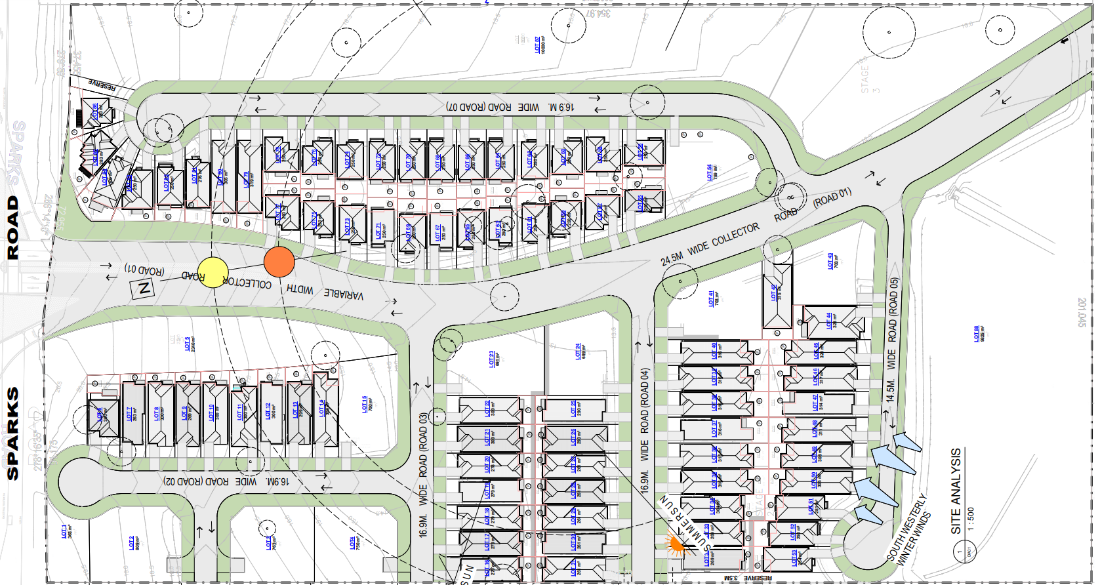
Figure 9: Approved subdivision plan under DA/1176/2017
DA/1176/2017/A

On 30 November 2021 modification application DA/1176/2017/A was lodged with Central Coast Council. This modification application sought to amend DA/1176/2017 as follows:

- Consolidation of 33 Lots into 1 Lot.
- Reduction in total lots from 88 Lots to 57 Lots.
- Removal in total number of housing (small lot housing) provided from 75 to 43.
- Change in use of the land being altered originally approved for the purpose of residential accommodation (dwelling houses) and now being vacant.
- Changes to the location and function of Road 6.
- Changes to the location and functions of the approved temporary basin.

The purpose of this modification application was to facilitate the delivery of a large residue lot through the consolidation of 33 residential lots. This residue lot was to contain the residential flat buildings that are the subject of this development application. The proposed subdivision pattern is shown in the below figure.

On 13 July 2022 Central Coast Council refused modification application for the following reasons:

- The consent authority was not satisfied that the development is substantially the same development as the development for which the consent was originally granted, in accordance with Section 4.55 (2)(a).
- The consent authority was not satisfied that objectives of the R1 General Residential zone were being met.
- The application does not comply with the objectives and controls of Chapter 6.5 – Warnervale South.
- The application did not contain sufficient information to accurately represent the proposed development or to properly assess the likely impacts of the development.

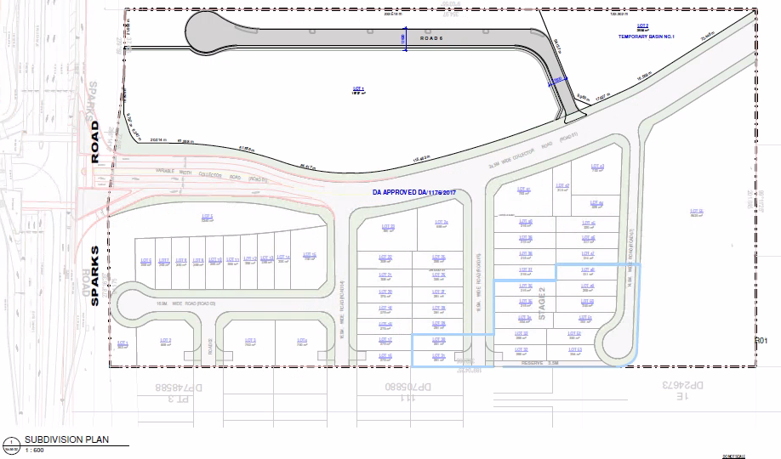
Figure 10: Subdivision plan under DA/1176/2017/A

- STATUTORY CONSIDERATIONS

  - Environmental Planning and Assessment Act 1979

When determining a development application, the consent authority must take into consideration the matters outlined in Section 4.15(1) of the Environmental Planning and Assessment Act 1979 (‘EP&A Act’). These matters as are of relevance to the development application include the following:

- the provisions of any environmental planning instrument, proposed instrument, development control plan, planning agreement and the regulations
(i) any environmental planning instrument, and
(ii) any proposed instrument that is or has been the subject of public consultation under this Act and that has been notified to the consent authority (unless the Planning Secretary has notified the consent authority that the making of the proposed instrument has been deferred indefinitely or has not been approved), and
(iii) any development control plan, and
(iiia) any planning agreement that has been entered into under section 7.4, or any draft planning agreement that a developer has offered to enter into under section 7.4, and
(iv) the regulations (to the extent that they prescribe matters for the purposes of this paragraph),
that apply to the land to which the development application relates,
- the likely impacts of that development, including environmental impacts on both the natural and built environments, and social and economic impacts in the locality,
- the suitability of the site for the development,
- any submissions made in accordance with this Act or the regulations,
- the public interest.

These matters are further considered below.

It is noted that the proposal was referred to the following agencies:

- Rural Fire Service as the site is bush fire prone land (s4.14 of the EP&A Act)

- Transport for NSW as the site has a frontage to a classified road (Cl 2.119 of the Transport and Infrastructure SEPP)

  - Environmental Planning Instruments, proposed instrument, development control plan, planning agreement and the regulations

The relevant environmental planning instruments, proposed instruments, development control plans, planning agreements and the matters for consideration under the Regulation are considered below.

- Section 4.15(1)(a)(i) - Provisions of Environmental Planning Instruments

The following Environmental Planning Instruments are relevant to this application:
- State Environmental Planning Policy (Planning Systems) 2021
- State Environmental Planning Policy 65 – Design Quality of Residential Apartment Development
- State Environmental Planning Policy (Transport and Infrastructure) 2021;
- State Environmental Planning Policy (Resilience and Hazards) 2021 (Resilience and Hazards SEPP)
- State Environmental Planning Policy (Building Sustainability Index: BASIX) 2004;
- State Environmental Planning Policy (Biodiversity and Conservation) 2021
- Wyong Local Environmental Plan 2013
- Central Coast Local Environmental Plan 2022

A summary of the key matters for consideration arising from these State Environmental Planning Policies are outlined in Table 3 and considered in more detail below.

Table 3: Summary of Applicable Relevant Planning Controls
EPI | Matters for Consideration | Complies (Y/N)
Planning Systems SEPP | - Schedule 6, Section 2 of the Planning Systems SEPP: declares the proposal as regionally significant development as the Capital Investment Value exceeds $30M | Y
SEPP 65 – Design Quality of Residential Apartment Development | - Clause 4(1) Applies to development that is at least 3 or more storeys (not including levels below ground level (existing) or levels that are less than 1.2 metres above ground level (existing) that provide for car parking)  - The proposal is two storeys and SEPP 65 therefore does not apply | N/A
Hazards and Resilience SEPP | - Section 4.6 - Contamination and remediation has been considered as part of DA 1176/2017 and the proposal is satisfactory subject to conditions. | Y
Transport and Infrastructure SEPP | - Section 2.119 Development with frontage to classified road  - Section 2.120 Impact of road noise or vibration on non-road development  - Section 2.122 Traffic-generating development | N
Biodiversity & Conservation SEPP | - Applies to the land  - No vegetation clearing proposed under this application | Y
BASIX SEPP | No compliance issues identified. | Y
Wyong LEP 2013 | - Clause 1.2 – Aims of plan. (j) to promote a high standard of urban design that responds appropriately to the existing or desired future character of areas | N
Central Coast LEP 2018 | - Clause 1.2 – Aims of plan. (h) to promote a high standard of urban design that responds appropriately to the existing or desired future character of areas | N
Wyong DCP 2013 | - Chapter 2.4: Multiple Dwelling Residential Development  - Chapter 3.1: Site Waste Management  - Chapter 6.5 Warnervale South | N

Consideration of the relevant SEPPs is outlined below.

State Environmental Planning Policy (State and Regional Development) 2011

The proposal is regionally significant development pursuant to Clause 2.19(1) as it satisfies the criteria in Section 2 of Schedule 6 of the Planning Systems SEPP as the proposal is general development, in the form of a residential flat building, with a capital investment value of over $30 million.

State Environmental Planning Policy No. 65 – Design Quality of Residential Apartment Development

Clause 4 establishes that SEPP 65 applies to residential flat buildings that are three or more storeys and have four or more dwellings. As the development is only two storeys in height SEPP 65 does not apply to the proposal.

State Environmental Planning Policy (Resilience and Hazards) 2021

State Environmental Planning Policy (Resilience and Hazards) 2021 commenced on 1 March 2022 incorporates and repeals the provisions of 3 SEPPs including State Environmental Planning Policy 55 – Remediation of Land.

The relevant provisions of the SEPP are addressed as follows:

Chapter 4 Remediation of Land

Section 4.6 of Chapter 4 requires that a consent authority must not consent to the carrying out of any development on land unless it has considered whether the land is contaminated.

The site is currently vacant; however, its former use was for rural residential purposes. Notwithstanding, the potential for contamination at the site was considered as part of DA 1176/2017. This DA determined that the site was suitable for residential purposes.

It is noted that the Preliminary Site Investigation (PSI) that was submitted under DA1176/2017 was resubmitted with the subject application. The PSI confirms the underlying soils at the site are not contaminated, and that soil quality at the 94 Sparks Road Hamlyn Terrace site is appropriate for the residential development proposed, subject to the recommendations of the report.

State Environmental Planning Policy (Transport and Infrastructure) 2021

The following provisions of State Environmental Planning Policy (Transport and Infrastructure) (2021) (Transport and Infrastructure SEPP) apply.

Section 2.119 - Development with frontage to classified road

The site has a frontage to Sparks Road which is a classified road. In accordance with Section 2.119 the consent authority must not grant consent to the development unless it is satisfied that:

- where practicable and safe, vehicular access to the land is provided by a road other than the classified road, and

The proposed development will be accessed from an internal road within an approved subdivision. No dwellings will be directly accessible from the classified road, however the wider site will have access to Sparks Road. The wider site’s access to Sparks Road was approved under DA/1176/2017.

- the safety, efficiency and ongoing operation of the classified road will not be adversely affected by the development as a result of—
- the design of the vehicular access to the land, or
- the emission of smoke or dust from the development, or
- the nature, volume or frequency of vehicles using the classified road to gain access to the land, and

The proposed development does not seek consent for any connection to Sparks Road. The wider site’s access to Sparks Road was approved under DA/1176/2017.

- the development is of a type that is not sensitive to traffic noise or vehicle emissions, or is appropriately located and designed, or includes measures, to ameliorate potential traffic noise or vehicle emissions within the site of the development arising from the adjacent classified road.

The proposed development is located adjacent to Sparks Road and associated noise impacts need to be considered. Consideration of the proposal against Section 2.120 – Impact of road noise or vibration on non-road development is provided below.

Section 2.120 - Impact of road noise or vibration on non-road development

Section 2.120 establishes that a consent authority must not grant consent to the development for a residential flat building unless it is satisfied that appropriate measures will be taken to ensure that the following LAeq levels are not exceeded:

- in any bedroom in the residential accommodation—35 dB(A) at any time between 10 pm and 7 am,
- anywhere else in the residential accommodation (other than a garage, kitchen, bathroom or hallway)—40 dB(A) at any time.

An Acoustic Report was submitted with the application and was reviewed by Council’s Environmental Health Team. The findings of this assessment concluded that the Acoustic Report does not clearly delineate the applicable noise mitigation measures required for each unit. Consequently, an appropriate assessment of the recommended acoustic mitigation measures cannot be undertaken.

Further, Part 2.9 of Chapter 6.5 of Wyong Development Control Plan 2013 (WDCP 2013) identifies that an acoustic barrier is required at the interface with Sparks Road. The WDCP 2013 establishes that this should take the form of a landscape mound with a 10m treatment zone, however an alternative solution can be considered.

The architectural plans illustrate a 1.8m high acoustic screen on the northern boundary with Sparks Road. However, neither the Statement of Environmental Effects nor Acoustic Report address the landscape mound requirement.

On 29 June 2022 a letter was issued to the applicant which outlined the above acoustic matters. The proposal does not satisfy the acoustic requirements of Section 2.119 or 2.120 of the Transport and Infrastructure SEPP.

Section 2.122 – Traffic Generating Development

Section 2.122 of the Transport and Infrastructure SEPP identifies traffic generating development as development specified in Schedule 3 of the SEPP which includes residential accommodation with 75 or more dwellings within 90m of a connection to a classified road.

The development application was referred to Transport for NSW (TfNSW) and two separate responses were received on 3 March 2022 and 10 June 2022 which on both occasions requested additional information relating to:

- Traffic generation rates
- Surveyed traffic volumes
- Sidra modelling
- Insufficient information on architectural plans
- Stormwater

With regard to traffic generation TfNSW noted that the Traffic Impact Assessment submitted with the DA utilises trip generation rates for high-density residential buildings. The Guide to Traffic Generating Developments define high density residential buildings as development that is
- close to public transport,
- greater than six storeys and
- almost exclusively residential in nature.

The proposal is therefore not considered a high-density residential development and the applied traffic generation rates are not considered appropriate for the development.

Given the above issues, TfNSW are unable to complete their assessment of the DA and consequently the provisions of Section 2.122 are not satisfied.

State Environmental Planning Policy (Biodiversity and Conservation) 2021

Chapter 2 Vegetation in non-rural areas

State Environmental Planning Policy (Vegetation in Non-Rural Areas) 2017 aims to protect the biodiversity values of trees and vegetation as well as the amenity of non-rural areas of the State. The policy applies to the site as it is zoned R1 General Residential.

No vegetation clearing is proposed under this application as approval was granted under DA/1176/2017 for the removal of vegetation within the wider site. Accordingly, no approvals are required under this SEPP.

State Environmental Planning Policy (Building Sustainability Index: BASIX) 2004

The application is supported by a BASIX certificate which confirms the proposal will meet the NSW government's requirements for sustainability, if built in accordance with the commitments in the certificate.

Central Coast Local Environmental Plan 2022

At the time the subject was lodged, the Central Coast Local Environmental Plan 2022 (CCLEP 2022) had not been gazetted and was a proposed instrument. The CCLEP 2022 was gazetted on 24 June 2022 and came into effect on 1 August 2022. The applicable CCLEP 2022 provisions to the site remain generally consistent with the provisions of the WLEP 2013.

This application is subject to the saving provision in clause 1.8A of the CCLEP 2022. Consideration of the zoning, development standards and relevant provisions of the CCLEP 2022 are discussed for the purpose of consistency.

Under the CCLEP 2022:

- the site remains zoned as R1 General Residential and residential flat buildings are permissible with consent
- there is no applicable maximum building height or FSR established for the site

The proposal is generally consistent with the development standards within the CCLEP 2022. However, the development does not satisfy the objectives of the LEP for the reasons outlined earlier in this report.

Wyong Local Environmental Plan 2013

The relevant local environmental plan applying to the site is the Gosford Local Environmental Plan 2014 (‘the LEP’). The aims of the LEP include:

(aa) to protect and promote the use and development of land for arts and cultural activity, including music and other performance arts,
  - to foster economic, environmental and social well being so that Wyong continues to develop as a sustainable and prosperous place to live, work and visit,
  - to encourage a range of housing, employment, recreation, human services and appropriately located tourism-related development in Wyong to meet the existing and future needs of residents and visitors,
  - to promote the efficient and equitable provision of public services, infrastructure and amenities,
  - to provide for a range of local and regional community facilities for recreation, culture, health and education purposes,
  - to apply the principles of ecologically sustainable development to guide future development within Wyong,
  - to conserve, protect and enhance the environmental and cultural heritage (both indigenous and non-indigenous) values of Wyong,
  - to protect areas of high scenic landscape value,
  - to maintain and enhance the existing character, amenity and environmental quality of Wyong,
  - to minimise risk to the community in areas subject to environmental hazards, including flooding, climate change and bush fires,
  - to promote a high standard of urban design that responds appropriately to the existing or desired future character of areas,
  - to encourage development that increases public transport patronage, walking and cycling.

The proposal is considered to be inconsistent with these aims, particularly (b), (h) and (j).

Zoning and Permissibility

The site is located within the R1 General Residential Zone pursuant to Clause 2.2 of the LEP as shown in the below figure.

Figure 11: 94 Sparks Road outlined in red, the site of the proposed development outlined in blue
According to the definitions in Clause 1.4 (contained in the Dictionary), the proposal satisfies the definition of a residential flat building which is a permissible use with consent in the Land Use Table in Clause 2.3.

residential flat building means a building containing 3 or more dwellings, but does not include an attached dwelling, co-living housing or multi dwelling housing.
Note— Residential flat buildings are a type of residential accommodation—see the definition of that term in this Dictionary.'

The zone objectives include the following (pursuant to the Land Use Table in Clause 2.3):

- To provide for the housing needs of the community.
- To provide for a variety of housing types and densities.
- To enable other land uses that provide facilities or services to meet the day to day needs of residents.
- To promote “walkable” neighbourhoods.
- To ensure that development is compatible with the scale and character of the local area and complements the existing streetscape.

The proposal is considered to be inconsistent with these zone objectives as it will result in residential dwellings that do not achieve a suitable degree of residential amenity due to the issues raised in this report.

The proposal is also considered to be inconsistent with the emerging character of the area due to the bulk and scale of the development.

General Controls and Development Standards

The LEP also contains controls relating to development standards, miscellaneous provisions, and local provisions. The controls relevant to the proposal are considered in Table 4 below.

Table 4: Consideration of the LEP Controls
Control | Requirement | Proposal | Comply
Height of buildings  (Cl 4.3(2)) | N/A | ~ 7.6m | N/A
FSR  (Cl 4.4(2)) | N/A | 0.57:1 | N/A
Relevant acquisition authority  (Cl 5.1) | The site is mapped for acquisition for stormwater management | A portion of 94 Sparks Road is mapped as stormwater management. This area correlates with the E3 zoned portion of the site (Figure 11).  The proposed development is located on a portion of the site which is not identified for acquisition. | Yes
Heritage  (Cl 5.10) | N/A | The site is not nearby to or likely to impact any heritage items listed under the LEP. | Yes
Flood Planning  (Cl 5.21) | The site is mapped as a Flood Planning Area | The wider site is mapped within the Flood Planning Area (refer to Figure 13)  However, the proposed development is located on a portion of the site which is not identified as containing flood prone land. Therefore, the proposal is not considered to be impacted by flooding constraints. | Yes
Public utility infrastructure (Cl 6.2) | Essential public utility infrastructure for the proposed development is available | Utility infrastructure is available in the surrounding area. | Yes
Acid sulphate soils  (Cl 7.1) | N/A | The proposal does not trigger any requirements under Clause 7.1. | Yes

The proposal is generally consistent with the development standards within the LEP. However, the development does not satisfy the objectives of the LEP for the reasons outlined earlier in this report.

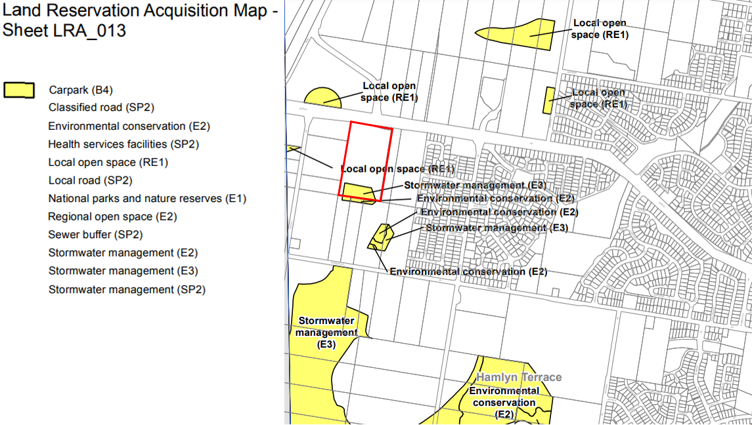
Figure 12: Land Reservation Acquisition Map

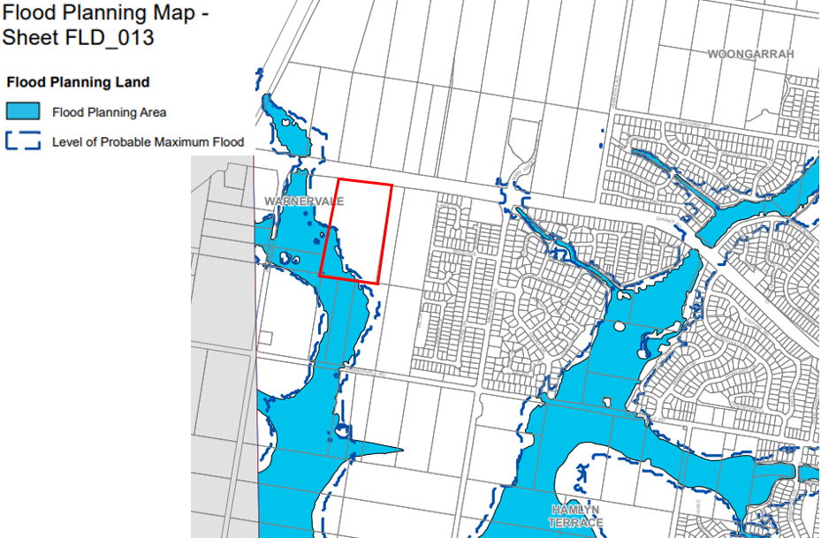
Figure 13: Extract Flood Planning Map

- Section 4.15 (1)(a)(ii) - Provisions of any Proposed Instruments

N/A

- Section 4.15(1)(a)(iii) - Provisions of any Development Control Plan

The following Development Control Plan is relevant to this application:

- Central Coast Development Control Plan 2022 (CCDCP 2022)
- Wyong Development Control Plan 2013 (WDCP 2013)

Central Coast Development Control Plan 2022

The Central Coast Development Control Plan 2022 (CCDCP 2022) came into force on the same date as CCLEP2022 (1 August 2022). Chapter 1.1 of the CCDCP 2022 contains savings provisions and provides that, consistent with the provisions of CCLEP2022, if a development application has been made before the commencement of this DCP and the application has not been finally determined before that commencement, the application must be determined as if the DCP had not commenced.

Based on the above, this application has been considered against the Wyong Development Control Plan 2013.

Wyong Development Control Plan 2013

The relevant sections and provisions of the WDCP 2013 are considered below.

Chapter 1.2 - Notification of Development Proposals
Chapter 2.4 - Multiple Dwelling Residential Development
Chapter 2.11 - Parking and Access
Chapter 3.1 - Site Waste Management
Chapter 6.5 – Warnervale South

The proposal has been assessed in accordance with the relevant provisions of WDCP 2013. The key controls of the WDCP 2013 are discussed below.

Section | Comment | Comply
Chapter 2.4 Multiple Dwelling and Residential Development
Section 3.0 Scale
3.1 – Height | The WDCP 2013 establishes a maximum height limit of two storeys with a ceiling height control of 7m above natural ground level.  The plans submitted with the application do not include RLs for the top of the building including the proposed privacy screening and as such the maximum building height could not be accurately determined.  The development exceeds the 7m ceiling height limit by approximately 600mm. This exceedance contributes to the scale of the development and also results in adverse solar access and privacy impacts within the development.  The proposal is two storeys in height; however, it includes rooftop terraces which further add to the scale of the development. These terraces also result in a poor amenity outcome for future residents in terms of privacy as only low- level walls are provided between these terraces facilitating view lines.  It is noted that the rooftop terraces do not include any shading devices, which would make these spaces unusable in summer months. The addition of such devices would further add to the bulk and scale of the building.  The proposed height variation, as well as extent of excavation proposed, results in a development that is out of scale with the desired future character for the area and is inconsistent with the objectives and controls relating to height contained in Chapter 2.4 of WDCP 2013. | No
3.2 – Site coverage | The WDCP 2013 requires a minimum of 25% of the site area at ground level to be soft landscaping, excluding all hardstand areas.  The architectural plans submitted state that a soft landscaping area of 31.6% (7,380m²) is provided. However, this area includes the area to the south of the site for the future detention basin and does not form part of the subject application. Further, the calculations incorrectly include footpaths that provide pedestrian access to and along the collector road. Consequently, the proposed quantum of soft landscaping area is inaccurate and unclear.  Notwithstanding, it is noted that the soft landscaping areas includes 3 x internal courtyards which are at basement level and will receive limited solar access. In addition, a large area of the soft landscaping comprises an APZ on the eastern boundary which provides minimal planting.  It is therefore considered that the proposed soft landscaping areas are low quality and will provide limited relief where the development interfaces with adjoining properties. This is largely due to the proposed density and resultant configuration of the development.  The development is therefore inconsistent with the objectives relating to site coverage contained in Chapter 2.4 of WDCP 2013. | No
4.0 Built Form
4.1 Construction and appearance of development | The proposal has a length of approximately 230m. Only 3 breaks are provided between Buildings A, B, C and D when viewed from the collector road and private road. In addition, the proposed design is largely repetitive as it presents to the public domain. Consequently, it will be difficult to discern the separation of the buildings into 4 separate blocks, resulting in a poor urban design outcome. | No
4.2 Cut and Fill | Part 4.2 of Chapter 2.4 of WDCP 2013 contains requirements for cut and fill to ensure development responds to the natural topography of the site. The documentation submitted with the application does not clearly detail the extent of earthworks across the site.  Notwithstanding, in some areas the proposed earthworks result in floor levels being in excess of 1.5m above ground level. In addition, a number of dwellings are set below natural ground level, for example the north facing units within Building A are approximately 1.5m below natural ground level. This will limit the ability of these dwellings to achieve a suitable level of solar access or to be provided with a suitable outlook.  Furthermore, the proposal includes 3 x internal courtyards which are at basement level, requiring excessive excavation works. It is considered that these spaces should be provided at ground level, minimising the extent of cut required. This would also enable these spaces to be accessible from ground floor level. | No
4.3 Building Lines | The WDCP 2013 establishes the following setbacks for the site:  Control Proposed Complies  Northern Boundary: 7.5m 4m to 7.5m No  Western Boundary: 6m 3.5m to 6m No  Eastern and southern boundaries: 4.5m from private road 1m to 4.5m No  As demonstrated above, the proposal is non-compliant with the applicable setback controls, resulting in a development that is excessive in terms of its bulk and scale.  In particular, it is noted that the proposed setbacks limit the ability to provide adequate landscaping to soften the development. | No
4.4.2 Resident Parking | Resident parking is to be provided in accordance with the following requirements:  Dwelling Type No. of spaces  Studio/ 1 bedroom unit 1  2 bedroom unit 1.2  3 bedroom unit 1.5  Visitor 1 per 5 units  A total of 183 resident spaces are required to be provided in accordance with the requirements of the WDCP 2013.  277 resident spaces are proposed resulting in an excess of 94 resident spaces.  The excess car parking proposed is not supported and contributes to the bulk and scale of the building due to the extent of cut and fill required to accommodate the basements, as is discussed later in this table in Section 5.1 Floor Space Ratios.  Furthermore, the architectural plans for the proposed basement car parking indicates the provision of 130 tandem/ stacked parking spaces. Chapter 2.11 Parking and Access of the WDCP does not support the provision of stacked parking for anything other than dwelling houses and dual occupancies. The proposed stacked parking is therefore not supported. | No
4.4.3 Visitor Parking | Visitor parking is to be provided in accordance with the following requirements:  Dwelling Type No. of spaces  Visitor 1 per 5 units  A total of 32 visitor spaces are required to be provided in accordance with the requirements of the WDCP 2013.  25 visitor spaces are proposed resulting in a shortfall of 7 visitor spaces. This shortfall in spaces is not supported. | No
5.0 – Density
5.1 – Floor Space Ratios | The WDCP establishes a maximum FSR of 0.6:1 for the site. The architectural plans submitted state an FSR of 0.57:1 is proposed based on a Gross Floor Area (GFA) of 11,260m².  However, these plans have not calculated the proposed GFA in accordance with the definition included within the WLEP. In particular:  - The GFA calculations do not include parking areas within the basement that are above the parking required by the WDCP. An overall excess of 87 car parking spaces are proposed. The area associated with these parking spaces should be included within the GFA calculations.  - The GFA calculations submitted have not included internal hallways.  - The plans illustrate an entryway into dwellings which have not been included in the GFA calculations. It is unclear from the plans submitted whether these spaces have enclosing walls greater than 1.4m and as such whether they are to be included in the GFA calculations.  Subject to the inclusion of the above elements, the proposal will significantly exceed the FSR of 0.6:1 for the site, resulting in a development that is excessively bulky and inconsistent with the future desired character of the area.
6.0 – Amenity
6.1 Private Open Space | The WDCP 2013 requires that each dwelling within a residential flat building is provided with a balcony, terrace or courtyard comprising at least 10m².  10% of units proposed do not achieve the minimum 10m² requirement for private open space.  A further 6% of units rely upon roof top terraces for achieving the 10m² requirement for private open space. The usability of these spaces is limited as they are accessed via spiral staircases and are therefore not directly accessible from a living area. In addition, these spaces are not provided with any form of shading device resulting in a poor amenity outcome.  The proposed roof top terraces are not supported as they are only provided with low level walls, resulting in inadequate screening and adverse privacy impacts for future residents. | No
6.2 Communal Open Space | The WDCP requires communal open space in two locations at a minimum rate of 10m² per dwelling with a minimum width of 5m, equalling a requirement of 1,600m².  In addition, open space is to be located to increase the potential for residential amenity by designing buildings which:  - are sited to allow for landscape design;  - are sited to optimise daylight access in winter and shade in summer;  - have a pleasant outlook;  - have increased visual privacy between apartments.  The plans submitted indicate a communal open space of 3,710m². However, 2,934m² is located on the eastern side of the private road and is therefore not directly accessible from the dwellings.  The proposal also includes 3 x internal courtyards in the middle of Buildings A, B and C. These areas cannot be considered as communal open space as they are at basement level, not ground level. Consequently, these spaces are not directly accessible or usable. | No
6.3 – Solar Access | The site is generally aligned north-south with good solar access opportunities to the north, east and west. However, approximately 50% of the proposed apartments are aligned with the internal driveway or are orientated south-west towards the collector road. These apartments will not be able to achieve at least 3 hours of solar access in mid-winter due to their orientation and internal configuration.  The WDCP 2013 requires that a maximum of 10% of dwellings have a southerly aspect. 11.8% of units are orientated to the south.  A number of units are also positioned below ground level and will be overshadowed by fences and retaining walls. In addition, the kitchen/ living areas of studios D-UG111 and D-112 have no windows and therefore no access to natural light.  On this basis, the development has not been designed to maximise solar acces for future occupants and is inconsistent with the objectives and requirements of Section 6.3 of the Wyong DCP. | No
6.4 – Privacy | The objects of Section 6.4 of the WDCP 2013 seek to:  - provide and maintain reasonable levels of visual privacy both internally and externally, during day and night  - maximise outlook and views from living rooms and private open space without compromising visual privacy  - ensure a high level of amenity by protecting the privacy of residents both within the apartments and in private open space areas  The WDCP 2013 establishes the following separation distance controls for the proposed development:  Up to 4 storeys  - 12m between habitable rooms  - 9m between habitable rooms and non-habitable rooms  - 6m between non-habitable rooms  There are numerous examples where habitable rooms and balconies are provided with less than 12m separation distance. This includes across the internal courtyards of Buildings A, B and C and between Buildings A and B and Buildings C and D. In particular, only 5m of separation is provided between balconies of Building C and D.  Bedroom windows are also provided to the breezeways which provide access to the units, resulting in a poor privacy outcome for future residents.  The proposal includes terraces on the rooftop which have low walls separating terraces from one another. These are inadequate to mitigate privacy impacts and results in low levels of privacy for future occupants of the development.  These rooftop terraces also contribute to the overall bulk of the development and result in a streetscape outcome that is inconsistent with the future character of the locality.  On this basis, the proposal does not satisfy the objectives of Section 6.4. | No
8.0 – Stormwater Management
8.0 – Stormwater Management | Section 8 of the WDCP 2013 seeks to ensure that land can be adequately drained for the health and convenience of residents, and that the development does not contribute to drainage or flooding problems elsewhere.  The Applicant has provided a road and drainage design for the proposed private access road. The drainage design needs to cater for the fully developed upstream drainage catchment on the northern side of sparks road (i.e. part of the Warnervale Town Centre) and to the east (NSW Department of Education).  The public drainage infrastructure from upstream is proposed to be located within the private road. Council would need to agree and approve a drainage easement being created that would benefit council so that access could be legally gained to undertake any future upgrade/maintenance. Council currently do not support this approach given that it is a major trunk drainage system and is conveying stormwater from upstream subdivisions. | No
9.0 – Landscape
9.1.2 Deep Soil Zones | A minimum 50% of the required soft landscaped area of the site at ground level shall be a deep soil zone. The proposal complies with this requirement. | Yes
10.0 – Sustainability
10.1.1 General Requirements – Waste Management | Kerbside waste collection is proposed for the development. Three waste storage rooms are provided at ground floor level adjacent to the private road. Bins within these rooms will be required to be wheeled to the kerb for collection.  This approach is not supported as it will result in approximately 39 x 1,100l or 179 240l bins waste and recycling bins placed on the kerb each week together with 32 x 240l green bins every fortnight. It is considered that this will result in adverse impacts on the amenity for future occupants of the development. | No
12.0 – Social Dimensions
12.1 – Housing Choice | The WDCP establishes that a variety of dwelling types is encouraged between one, two, three and four bedroom apartments; particularly in large residential flat developments and on the ground floor.  The proposed development provides the following unit mix:  Unit type Number Percentage  Studio 12 7.5%  1 bedroom 40 25%  2 bedroom 104 65%  3 bedroom 4 2.5%  The proposed unit mix does not provide an appropriate variety of dwelling types. In particular, only 4 x 3 bedroom units are proposed which equates to 2.5% of the overall development. This limits the ability of the development to cater for different household requirements.  It is noted that the WDCP does not provide minimum apartment size requirements. While the development is not subject to the Apartment Design Guide, it has been referenced in this instance as a best practice guide for apartment design.  18 (11%) of units within the development do not achieve the minimum apartment size requirements under the ADG. | No
Chapter 6.5 – Warnervale South
2.0 – Subdivision Design and Environmental Considerations
2.1 – Character consideration | The indicative structure plan for the Warnervale South identifies the site for medium density residential.  As discussed, the proposal is not considered to be consistent with the future desired character of the area. | No
2.4 – Road Layout and Hierarchy | The proposal is inconsistent with the indicative road layout plan for the precinct. This plan envisions the provision of a local road to the north and eastern site boundaries which connects to the collector (refer to below figure).  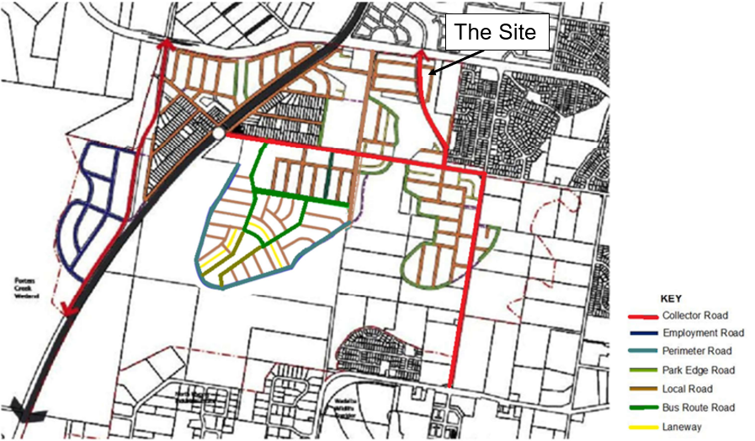  Under DA1176/2017 a public road with a 16.9m road reserve was approved. The subject DA now seeks a private road with a 10.5m road reserve, and therefore results in a development that is inconsistent with the indicative road layout plan.  An APZ is required from the eastern boundary. The NSW RFS will require the private driveway to be accessible for emergency vehicles. The private access would need to be designed and constructed to the requirements of NSW RFS Planning for Bushfire Protection standards to ensure heavy rigid vehicles could gain access where required. Insufficient information has been provided to confirm this and consequently the RFS are unable to issue concurrence. | No
2.9 Noise Assessment and Mitigation | Part 2.9 of Chapter 6.5 of Wyong DCP identifies that an acoustic barrier is required at the interface with Sparks Road. This should generally take the form of a landscape mound with a 10m treatment zone, however an alternative solution can be considered.  The architectural plans illustrate a 1.8m high acoustic screen on the northern boundary with Sparks Road. However, neither the Statement of Environmental Effects nor Acoustic Report address the landscape mound requirement.  This issue was raised in the correspondence dated 29 June 2022.  The proposal does not satisfy the provision so Part 2.9 of Chapter 6.5 of Wyong DCP. | No

In consideration of the above, the proposal is considered inconsistent with the WDCP.

Development Contributions
The site is subject to the Warnervale District Section 7.11 Contributions Plan. Notwithstanding, the proposal is recommended for refusal.

- Section 4.15(1)(a)(iiia) – Planning agreements under Section 7.4 of the EP&A Act

There have been no planning agreements entered into and there are no draft planning agreements being proposed for the site.

- Section 4.15(1)(a)(iv) - Provisions of Regulations
There are no specific matters under the Regulation that require further discussion.

  - Section 4.15(1)(b) - Likely Impacts of Development

The likely impacts of that development, including environmental impacts on both the natural and built environments, and social and economic impacts in the locality must be considered. In this regard, potential impacts related to the proposal have been considered in response to SEPPs, LEP and DCP controls outlined above. These matters are discussed in detail in Section 5 of this report and include:

- Context, Setting and the Built Environment
- Residential Amenity
  - Building Separation and Privacy
  - Unit Mix and Apartment Layout
  - Private Open Space
  - Communal Open Space
  - Solar Access
- Car Parking
- Waste Collection
- Acoustic Impacts
- Stormwater Management

  - Section 4.15(1)(c) - Suitability of the site

The proposal is considered to not be suitable for the site and is inconsistent with the future desired character of the area due to the bulk and scale of the development.

  - Section 4.15(1)(d) - Public Submissions

No public submissions were received on the subject application.

  - Section 4.15(1)(e) - Public interest

The proposal is considered to not be in the public interest and is inconsistent with the applicable planning controls as detailed within this report.

- REFERRALS AND SUBMISSIONS
  - Agency Referrals and Concurrence
The development application has been referred to various agencies for referral as required by the EP&A Act and outlined in the below table.

Both TfNSW and the NSW RFS requested additional information. However, given the decision to proceed to a determination of the application, the requested information was not requested of the applicant and consequently these agencies have not been furnished with the information they require to undertake an adequate assessment of the application.

Table 5: Concurrence and Referrals to agencies
Agency | Concurrence/  referral trigger | Comments  (Issue, resolution, conditions) | Resolved
Referral/Consultation Agencies
RFS | S4.14 – EP&A Act  Development on bushfire prone land | RFS NSW requested information to demonstrate the applications consistency with Appendix 2 of Planning for Bush Fire Protection 2019. | No
TfNSW | S2.122 of Transport and Infrastructure SEPP | TfNSW requested further information to address issued relating to the following:  - Traffic generation rates  - Surveyed traffic volumes  - Sidra modelling  - Insufficient information on architectural plans  - Stormwater | No

  - Council Officer Referrals

The development application has been referred to various Council officers for technical review as outlined Table 6.

Table 6: Consideration of Council Referrals
Officer | Comments | Resolved
Engineering | Council’s Engineering Officer reviewed the application and required amended and additional information to be provided from the applicant relating to traffic, stormwater and utilities. | No
Traffic | Council’s Traffic Engineer reviewed the application and required amended and/or additional information to be provided from the applicant relating to traffic and parking. | No
Urban Design | Council’s Urban designer reviewed the application and required amended and additional information to be provided by the applicant relating to a number of design matters. | No
Environment | Council’s Environment officer reviewed the application and supported the application subject to conditions. | Yes
Environmental Health | Council’s Environmental Health Officer reviewed the application and required amended and/or additional information to be provided from the applicant relating to acoustic impacts and mitigation. | No

  - Community Consultation
The proposal was notified in accordance with the Environmental Planning and Assessment Regulation 2000 and Chapter 1.2 -Notification of Development Proposals, from 5 November 2021 until 13 December 2021. The Council did not receive any public submissions on the proposal.

- KEY ISSUES
The following key issues are relevant to the assessment of this application having considered the relevant planning controls and the proposal in detail:

  - Context, Setting and the Built Environment
It is acknowledged the WLEP does not establish a building height and FSR control for the site. Notwithstanding, the WDCP establishes a maximum building height of 2 storeys, maximum ceiling height of 7m and an FSR of 0.6:1.

The development is two storeys in height, however it includes rooftop terraces which add additional bulk to the development. Further, the proposed ceiling height is approximately 7.6m. The proposed height variation is compounded by the extent of excavation proposed, which increases the overall height of the development above natural ground level.

The plans submitted indicate an FSR of 0.57:1 based on a GFA of 11,260m². As discussed, these plans have not calculated the proposed GFA in accordance with the definition included within the WLEP. Once the parking areas, hallways and entryways to dwellings are included the proposal will significantly exceed the FSR control of 0.6:1.
The proposal has a length of approximately 230m. Only 3 breaks are provided between Buildings A, B, C and D when viewed from the collector road and private road. In addition, the proposed design is largely repetitive as it presents to the street and driveway/internal road. Consequently, it will be difficult to discern the separation of the buildings into 4 separate blocks, result in a poor urban design outcome.

The development incorporates numerous non-compliances with the applicable setback controls and result in a development that is excessive in terms of its bulk and scale. Further, these variations limit the proposals, ability to provide adequate landscaping to soften its interface with the streetscape and surrounding development.

In consideration of the above, the bulk and scale of the proposed development is considered inappropriate for the site and will result in a development that is out of character with the future desired character of the area.

  - Residential Amenity
Building Separation and Privacy

There are numerous examples where habitable rooms and balconies do not achieve the minimum separation distance requirements established by the WDCP. This includes:

- across the internal courtyards of Buildings A, B and C
- between Buildings A and B
- between Buildings C and D

The limited separation distance provided is a result of the proposed yield and excessive density proposed at the stie. An example of some of these areas of non-compliance are provided in figures 14, 15 and 16.

It is also noted that bedroom windows are provided to the breezeways/ corridors at both ground and first floor level, which provide access to the units. This results in a poor privacy outcome as there will be direct view lines into bedrooms.

The proposal includes terraces on the rooftop which have low walls separating terraces from one another. These walls are inadequate to mitigate privacy impacts and results in low levels of privacy for future occupants of the development.

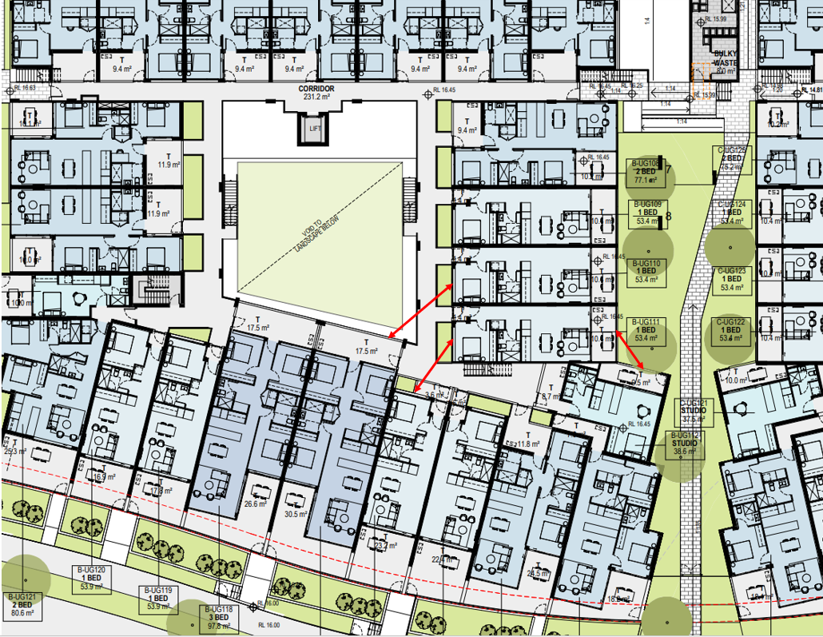
Figure 14: Extract showing separation distance non compliance within Building B

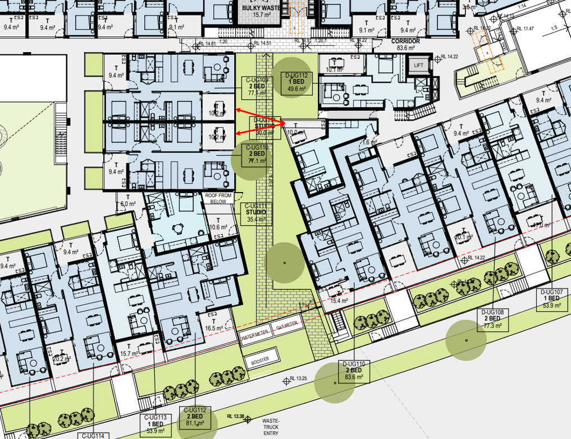
Figure 15: Approximately 5m separation distance between balconies between Buildings C and D
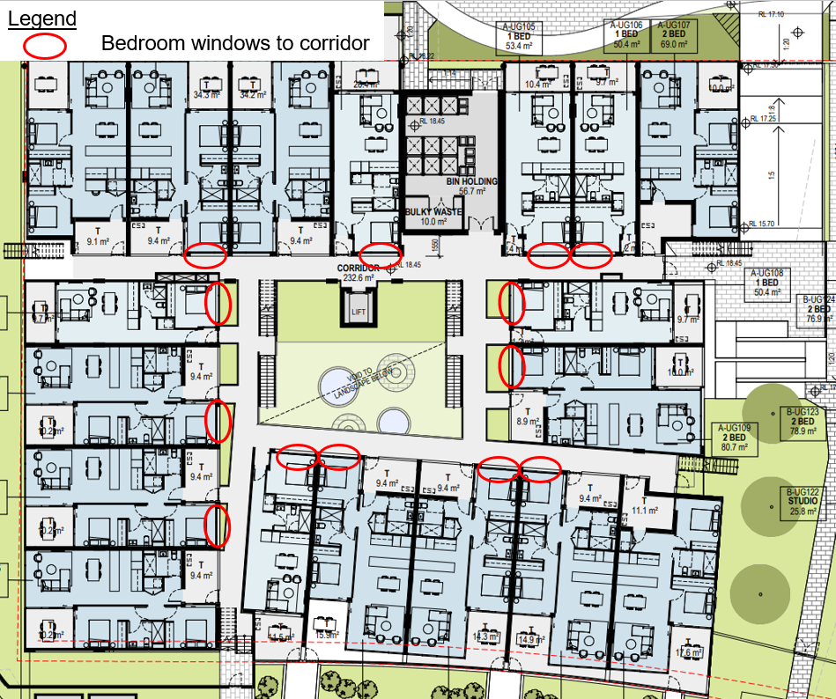
Figure 16: Example of bedroom windows located adjacent to breezeway/ corridor in Building A
Unit Mix and Apartment Layout

The proposed unit mix does not provide an appropriate variety of dwelling types. In particular, only 4 x 3 bedroom units are proposed which equates to 2.5% within the entire development. This unit mix limits the ability of the development to cater for different household requirements.

It is noted that the WDCP 2013 does not provide minimum apartment size requirements. While the development is not subject to the ADG, it has been referenced in this instance as a best practice guide for apartment design.

18 (11%) of units within the development do not achieve the minimum apartment size requirements under the ADG, adversely impacting the amenity of these dwellings.

Private Open Space

The WDCP 2013 requires that each dwelling within a residential flat building is provided with a balcony, terrace or courtyard comprising at lease 10m².

10% of units proposed do not achieve the minimum 10m² requirement for private open space which is not supported.

A further 6% of units rely upon roof top terraces for achieving the 10m² requirement for private open space. The usability of these spaces is limited as they are accessed via spiral staircases and are therefore not directly accessible from a living area.

These roof top terraces are also not provided with any form of shading device and will result in adverse privacy impacts to adjoining properties as they are only provided with low level walls, resulting in inadequate screening.

Based on the above, the proposed private open space would result in a poor amenity outcome for future residents.

Communal Open Space

In accordance with the WDCP 2013, 1,600m² of communal open space is required to be provided at the site. The architectural plans submitted state a communal open space area of 3,710m² is provided within the development. However, 2,934m² of this space is located on the eastern side of the private road and is not directly accessible from the dwellings.

Further, the remaining 776m² of communal open space is located in the pedestrian access links between Buildings A and B, B and C, and C and D. Each of these spaces is located on the southern site of a building and will therefore be overshadowed, resulting in low amenity for users.

The proposal also includes 3 x internal courtyards in the middle of Buildings A, B and C. It is noted that these areas cannot be considered as communal open space as they are at basement level, not ground level. These spaces are not directly accessible or usable.

Based on the above, the proposed communal open space would result in a poor amenity outcome for future residents.

Solar Access

The site is generally aligned north-south with good solar access opportunities to the north, east and west. However, approximately 50% of the proposed apartments are aligned with the internal driveway or to the south-west facing the collector road. These apartments will not be able to achieve at least 3 hours of solar access in mid-winter due to their orientation and internal configuration.

The WDCP 2013 requires that a maximum of 10% of dwelling have a southerly aspect. 11.8% of units are orientated to the south.

A number of units are also positioned below ground level and will be overshadowed by fences and retaining walls. In addition, the kitchen/ living areas of studios D-UG111 and D-112 have no windows and therefore no access to natural light or ventilation.

On this basis, the development has not been designed to maximise solar acces for future occupants and is inconsistent with the objectives and requirements of Section 6.3 of Chapter 2.4 of WDCP 2013.

  - Car Parking
A total of 183 residential and 32 visitor car parking spaces are required to be provided in accordance with the requirements of the WDCP. 277 residential and 25 visitor car parking spaces are proposed resulting in an excess of 87 spaces.

The excess car parking proposed is not supported as it contributes to the bulk and scale of the building due to the extent of cut and fill required to accommodate the basement level.

Furthermore, the architectural plans for the proposed basement car parking indicates the provision of 130 tandem/ stacked parking spaces. Chapter 2.11 Parking and Access of the WDCP does not support the provision of stacked parking for anything other than dwelling houses and dual occupancies. The proposed stacked parking is therefore not supported.

  - Waste Management
Kerbside waste collection is proposed for the development. Three waste storage rooms are provided at ground floor level adjacent to the private road. Bins within these rooms will be required to be wheeled to the kerb for collection.

This approach is not supported as it will result in approximately 39 x 1,100l or 179 240l waste and recycling bins placed on the kerb each week together with 32 x 240l green bins every fortnight. It is considered that this will result in adverse impacts on the amenity for future occupants of the development.

  - Acoustic Impacts
The subject site is located to the south of Sparks Road, which is a classified road. Chapter 6.5 of WDCP 2013 identifies that an acoustic barrier is required at the sites interface with Sparks Road. This is generally required take the form of a landscape mound with a 10m treatment zone, however an alternative solution can be considered. The architectural plans illustrate a 1.8m high acoustic screen on the northern boundary with Sparks Road.

The Acoustic Report submitted with the application identifies that the proposal can achieve compliance with the acoustic requirements established by the Transport and Infrastructure SEPP for developments adjoining a classified road, subject to the implementation of a number of mitigation measures. However, Council’s Environmental Health Team advised that the report does not clearly delineate the noise mitigation measures for each unit.

In addition, the Acoustic Report does not assess whether waste collection will adversely impact upon the amenity of the surrounding neighbourhood and future residents of the Residential Flat Building.

On 29 June 2022 a letter was issued to the applicant advising of the above acoustic matters.

It is considered insufficient information has been received to adequately assess noise impacts to and from the proposed development.

  - Stormwater Management
The Applicant has provided a road and drainage design for the proposed private access road. The drainage design needs to cater for the fully developed upstream drainage catchment on the northern side of Sparks road, which includes part of the Warnervale Town Centre, and to the east which includes the NSW Department of Education site.

The public drainage infrastructure from upstream is proposed to be located within the private road. Council would need to agree and approve a drainage easement being created that would benefit council so that access could be legally gained to undertake any future upgrade/maintenance. Council currently do not support this approach given that it is a major trunk drainage system and is conveying stormwater from upstream subdivisions.

  - Inconsistency with DA/1176/2017
As discussed, the subject application is reliant upon modification application DA/1176/2017/A.
The purpose of this modification application was to facilitate the delivery of a large residue lot through the consolidation of 33 residential lots approved under DA/1176/2017. The resultant residue lot would contain the residential flat buildings that are the subject of this development application.

However, on 13 July 2022 Central Coast Council refused modification application for the following reasons:

- The consent authority was not satisfied that the development is substantially the same development as the development for which the consent was originally granted, in accordance with Section 4.55 (2)(a).
- The consent authority was not satisfied that objectives of the R1 General Residential zone were being met.
- The application does not comply with the objectives and controls of Chapter 6.5 – Warnervale South.
- The application did not contain sufficient information to accurately represent the proposed development or to properly assess the likely impacts of the development.

Consequently, the subject application is inconsistent with the approved underlying subdivision pattern. This inconsistency cannot be supported given the proposed development relies upon the underlying approval to provide access to the site and to address a range of matters including contamination and vegetation clearing.
  - Inadequate Information
As detailed within this report, the application did not include sufficient information to adequately assess the proposed development. This included:

- A site survey showing the exact area and dimensions to illustrate the site area;
- The architectural plans do not include spot levels at ground level on floor plans or elevations and do not include adequate RLs to determine the height of the development and extent of excavation and fill, floor to ceiling heights and level of private open space.
- The FSR drawings are not calculated in accordance with the definition of FSR and GFA included within the WLEP 2013
- No elevations have been submitted that show the building without boundary fences which conceal the residential flat buildings.
- The shadow diagrams do not include shadows cast by fences and topography
- The Statement of Environmental Effects (SEE) and Acoustic Report do not consider requirement for the acoustic wall required by 2.9 of Chapter 6.5 of Wyong DCP and the acoustic report does not clearly delineate the required noise mitigation recommendations.
- Information for TfNSW to adequately assess the proposed development. Accordingly, TfNSW requested information in relation to the following:
  - Traffic generation rates
  - Surveyed traffic volumes
  - Sidra modelling
  - Insufficient information on architectural plans
  - Stormwater
- Information to satisfy NSW RFS relating to the application’s consistency with Appendix 2 of Planning for Bush Fire Protection 2019.

- CONCLUSION

This development application has been considered in accordance with the requirements of the EP&A Act and the Regulations as outlined in this report. Following a thorough assessment of the relevant planning controls, and the key issues identified in this report, it is considered that the application cannot be supported.

- RECOMMENDATION

That the Development Application DA/1888/2021 for 4 x 2 storey residential flat building comprising a total of 160 dwellings, civil services, and associated landscaping at 94 Sparks Road, Hamlyn Terrace be REFUSED pursuant to Section 4.16(1)(a) of the Environmental Planning and Assessment Act 1979 subject to the draft reasons for refusal attached to this report at Attachment A.

The following attachments are provided:
- Attachment 1: Draft reasons for refusal
- Attachment 2: Architectural Plans
- Attachment 3: Statement of Environmental Effects

